Email Fix

If you are logging into your email and you are still not receiving any new emails, then you need to do the following:
Go to the top right hand corner of your email. Click on your name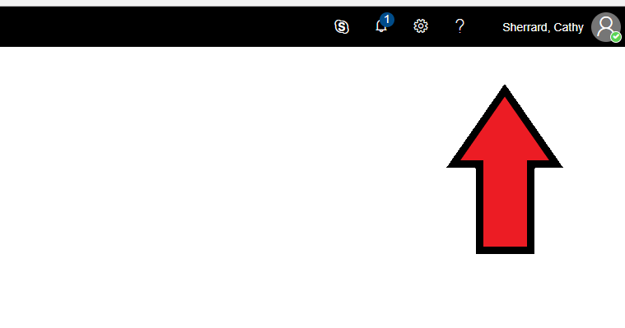and when the drop down menu appears, click “Sign Out”. 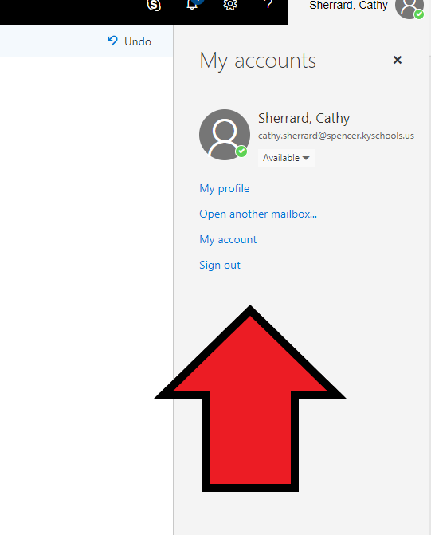
Once your email account is closed, you will see a notice from Microsoft that “You signed out of your account”. Close the browser by clicking on the ‘X’ in the top right hand corner. Once you have closed the browser window, you can then reopen the browser and try to login to your email and see if you are in the new email/OneDrive.
If you are still having problems, please contact me at cathy.sherrard@spencer.kyschools.us and I will get with you as soon as possible.

